## **DALLE vs. Leonardo AI:**

## **Features and Capabilities**

**DALLE (DALL-E 3)** is like chatting with a super-talented artist who always gets what you mean—even when you’re vague. Thanks to its integration with ChatGPT, you just describe what you want in plain language and DALLE turns it into visuals, often with impressive nuance and accuracy. If you want to tweak or adjust parts of your image (like painting in missing elements or expanding the canvas), it’s easy with DALLE’s inpainting and outpainting features. Creating consistent characters or scenes from simple descriptions is also a breeze, making DALLE very approachable—no art degree required.

**Leonardo AI**, on the other hand, is more like having a customizable art studio at your fingertips. It’s built for people who either have a very specific vision or want to create a cohesive artistic style across different projects. One of its coolest features is the ability to train Leonardo AI with your own art, ensuring that all your images stay true to your style. You can fine-tune prompts, adjust model settings, and even upscale your creations to fix any image quality hiccups. Leonardo is perfect if you like to experiment and don’t mind digging into more advanced tools.

## **Image Quality, Prompt Accuracy, and Style Flexibility**

Both DALLE and Leonardo can produce stunning, high-quality images.

* **DALLE** shines at making realistic, detailed imagery just from natural language prompts. It’s become much better at understanding and following complex instructions, so even tricky or abstract ideas come out the way you imagined.
* **Leonardo AI** focuses on style consistency and lets you control how exactly your images meet the prompt. Whether you’re creating a fantasy world or a branded series, you’ll appreciate its ability to stick to a designated look, especially with custom-trained models.

## **Usability and User Experience**

* **DALLE** keeps things simple and friendly. Its minimalist web and mobile interface is designed so anyone can jump right in, especially with the help of conversational AI through ChatGPT. You won’t be overwhelmed by options or technical jargon—just describe your idea and get creative.
* **Leonardo AI** gives creators more to play with. The interface remains accessible for beginners but packs advanced editing, animation tools, and a vibrant community with tutorials and support. If you want to go deep with your designs, Leonardo has everything you need.

## **Licensing and Terms:**

Ownership and commercial use are important, whether you’re making things for fun or business.

* **DALLE's images** fall under OpenAI’s general Terms of Use, so check their policies if you want detailed rights info. There’s a free option (with limits), and you can upgrade for bigger or team usage.
* **Leonardo AI** has clearer tiers: Paid subscribers keep full ownership and copyright on privately generated images. Free users can use images commercially, but Leonardo AI also has the right to reuse them. Anything you share publicly on their platform gives Leonardo broad rights to distribute and modify it, regardless of your subscript.  
    
  ***DALL-E Images:***

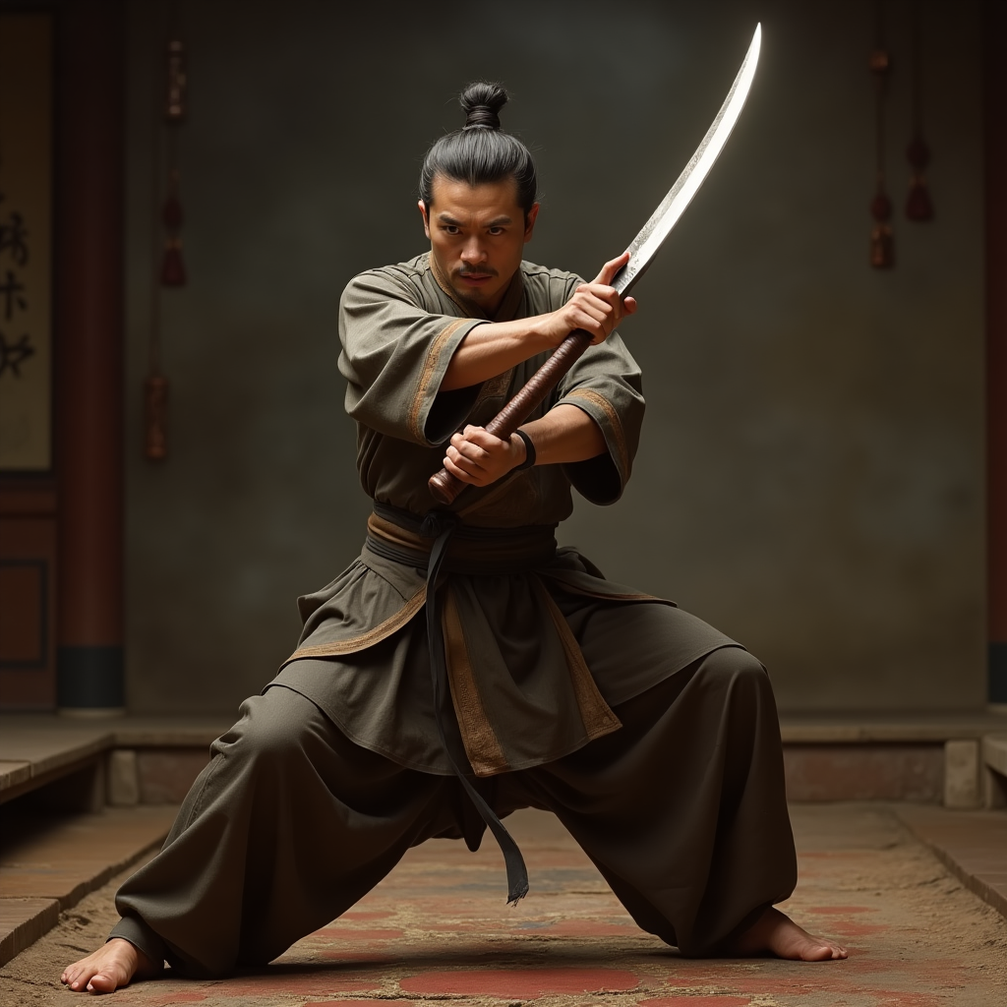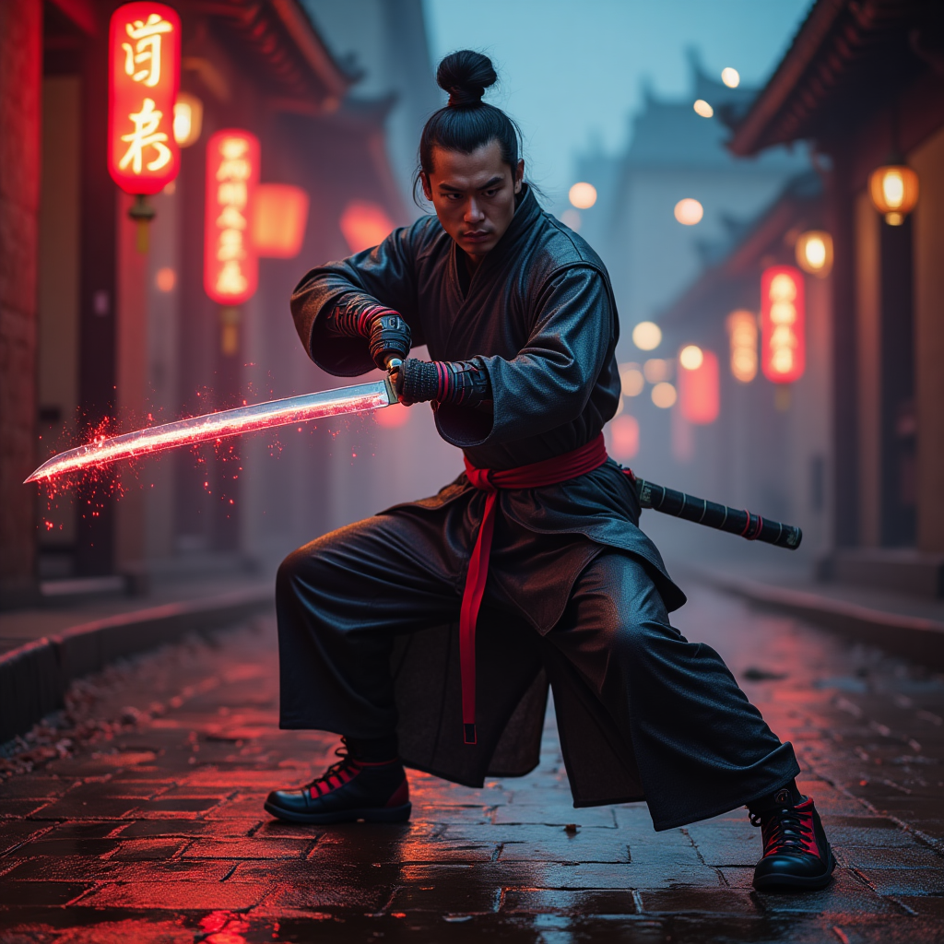

***Leonardo Images:***

